UNIT 7 (Cont.)
V. Look at the pictures and choose the best answer to complete each sentence.
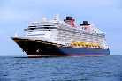
  - 1. My uncle travelled to Japan by……………..
    - A. boat
    - B. ship

    - C. canoe
    - D. barge

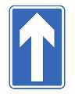
2. This sign says “………………..”
  - A. You must stop
  - B. You must not slow down

  - C. You can enter that road
  - D. You cannot go straight ahead
- 3. There are usually ………….on my way to school.
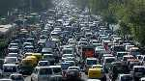
  - A. accidents
  - B. road works

  - C. railways
  - D. traffic jams
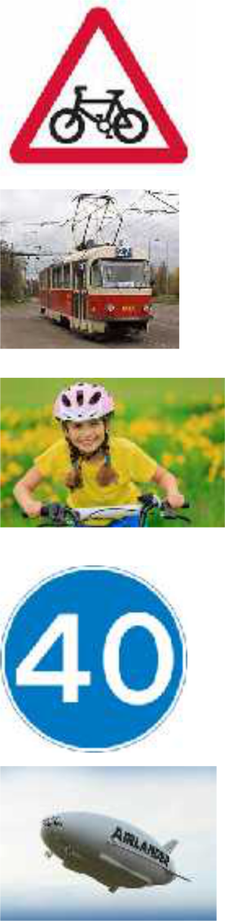
- 4. This road sign means “………………...”
  - A. Cycle route ahead
  - B. No cycling
  - C. Route for pedal cycles
  - D. Give way to bikes

- 5. Kelvin sometimes goes to university by ………
  - A. train
  - B. bus
  - C. tram
  - D. coach

- 6. You should wear a ……..when you ride a bike.
  - A. mask
  - B. helmet
  - C. scarf
  - D. seatbelt

- 7. This road sign shows “……………”

  - A. maximum speed
  - B. minimum speed
  - C. average speed
  - D. overtaking speed

- 8. Mr. Brown sometimes goes sightseeing by…….
  - A. flying boat
  - B. rocket

  - C. balloon
  - D. airship

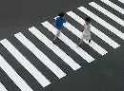
- This road sign means “…………….”
  - A. bump
  - B. no traffic

  - C. danger
  - D. give way

10.You must walk across the street at the………..

- A. pavement
- B. zebra crossing
- C. footpath
- D. roundabout

VI. Look at the following pictures. Use “used to” to write about the past and present simple tense to write about the present.
Past | Present simple
brother | he
ride | drive
work | car
1a……………..……………… | 1b…………………….…………
Mr. Vinh | he
train | fly
Ho Chi | plane
Minh City | 2b…………………..……………
2a………………..……………
Bob and Tina | they
walk | travel
school | bus
3a………….………….………… | 3b………………..………………
David | He
sail | travel
sightseeing | balloon
4a………………..…………… | 4b…………………..……………
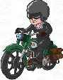
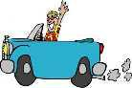
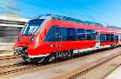
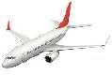
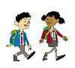
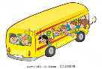
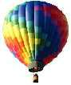

VII. Finish each of the following sentences in such a way that it is as similar as possible in meaning to the original sentence. Use the word given and other words as necessary. Do not change the form of the
given word.

1. Mr. and Mrs. Smith are flying to Ha Noi now. TRAVELLING

…………………………………………………………………………

2. Van hand a motorbike once, but he doesn’t any more. USED

…………………………………………………………………………

3. My father usualy goes to work by car. DRIVES

…………………………………………………………………………

4. This part of the city didn’t have traffic jams very often. USE

…………………………………………………………………………

5. I used to walk to school when I was young. FOOT

…………………………………………………………………………

VIII. Match a sentence in Column A with an appropriate sentence in Column B. (Use each sentence once only).

Column A

- 1. I was very fit when I was young.

- 2.The teachers at my school were kind

- 3.My brother’s room was so messy.

- 4.I had a dog when I was a kid.

- 5.My family had some lovely holidays.

- 6.When I was young, we didn’t have a car.

- 7.And we didn’t have central heating.

- 8.My uncle was a pilot for Vietnam Airlines.

- 9. My father was weak.

10.My brother was a soccer player.
Column B

- a.He used to smoke a lot.

- b.He used to play for the local team.

- c.It used to follow me everywhere.

- d.We used to go everywhere by bus.

- e.We used to freeze on winter mornings.

- f.He used to fly Airbus.

- g.He never used to tidy it at all.

- h. I used to do a lot of exercises.

- i.They used to help pupils.

- j. We used to go camping all over the country.

